Name:
Period 7 (1890 – 1945) Review Sheet

Welcome to Period 7! This period is the largest period of the APUSH curriculum, at 17%. Almost 1/5 of the exam will be devoted to this time period, so make sure you are familiar with it.
C
H
E
C
K

I
T

O
U
T
!

Potential Short Answer Questions/Essay Topics Include:
- Causes and effects of the following wars: the Spanish-American War, World War I, and World War II
- Reasons for overseas expansion in the late 19th century
- Comparing and Contrasting US foreign policy after WWI and WWII
- Turning Points: The Spanish-American War or The Progressive Era

Why were these years chosen for this period?
Using the census data from 1890, Frederick Jackson Turner believed the frontier was closed. This helped lead to overseas expansion. After the Spanish-American War, the US entered the Progressive Era, which could also be seen as a Turning Point. The 1920s, while “roaring,” saw the US become isolated. After entering the Great Depression, FDR became president and ushered in the New Deal. Finally, World War II ended in 1945.

Key vocabulary terms to know for this time period:
Check the following terms out on Quizlet HERE.
“Closing” of the Frontier: Frederick Jackson Turner's Frontier Thesis argued the frontier was "closed." Led many Americans to call for overseas expansion
Progressive Era: 1890 - 1920, Progressives tended to be women, middle class, and live in urban areas. Progressives sought to use government influence to solve societal problems.
Transition from Rural to Urban Society: US society adjusted as more people moved to cities - 1920 census - more people live in cities than rural areas
Harlem Renaissance: Celebration of African American culture through music, poetry, and writing. Key people - Langston Hughes, Claude Monet, Zora Neale Hurston
World War I: US entrance in 1917. US played a relatively minor role in the war, but large role in postwar negotiations.
Treaty of Versailles and League of Nations: Treaty that ended WWI; League led to debates over the role of the US in the world; ultimately, the US did NOT join the League
Great Migration: Mass movement of African Americans from the South to the North during WWI for economic opportunities
Red Scare: Fear of Communism after WWI, caused by: Russian Revolution, labor strikes post WWI, nativism; led to a crackdown on immigrants and radicals (suppression of rights)
Restrictive Immigration Quotas: 1921 and 1924 acts that severely limited immigration from Southern and Eastern Europe ("New immigrants")
Great Depression: Worst financial crisis in US history, led to calls for the creation of a stronger financial regulatory system
New Deal: Drew on ideas from the Progressive Era, sought to address causes of the Depression; faced opposition by the left and right; left a legacy of reforms that are still around today
World War II: US remained neutral until Pearl Harbor; US and Allies won due to: political and military cooperation, industrial production, and scientific advancements; US emerged as a world power
Japanese Internment: Japanese and Japanese Americans were placed in camps beginning in 1942; upheld by Korematsu v. US
Decision to drop the atomic bombs on Japan: Many reasons - save American lives, end the war quickly, etc.; raised questions about American values
Hold Up!

Watch THIS video on Period 7 before you proceed. (12 minutes)

1. Identify 3 reasons for US expansion overseas in the late 19th century.

The following questions are based on the Spanish-American War.
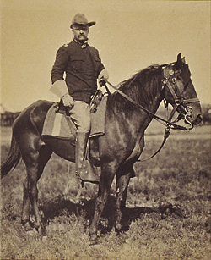
2. What were three causes of the Spanish-American War?

3. What did the US gain as a result of the Spanish-American War?

4. How did the Spanish-American War lead to debates in the US about foreign policy?

5. How can the Spanish-American War be seen as a turning point?

The following questions are based on the Progressive Era.

6. What were characteristics of Progressives?

7. How did Progressives reform the following areas of life?
- Businesses:
- Economy:
- Environment:
- Democracy:

8. Identify two important individuals and three amendments from the Progressive Era.
- Individuals:
- Three Amendments:

9. How could the Progressive Era be seen as a turning point?

The following questions are based on World War I.

10. What were reasons the US entered World War I?

11. How did the war affect African Americans and women?
- African Americans:
- Women:

12. How did President Wilson view the Treaty of Versailles? How did the Senate? What was its fate?
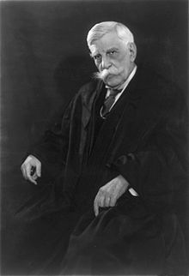
- Wilson’s view:
- Senate’s view:
- Treaty’s fate:

13. How were civil liberties limited during World War I?

The following questions are based on the 1920s.

14. What were three causes of the 1st Red Scare? What was a result?
- Causes:
- Effect:

15. What does a “Return to Normalcy” mean?

16. What type of foreign policy did the US pursue in the 1920s?

17. What were three reasons for African American migration to the North and West?

18. What was the Red Summer?

19. What happened to immigration in the 1920s?

20. How was the Trial of Sacco and Vanzetti an example of nativism?

21. How did women challenge gender roles in the 1920s?

22. Provide an example of conflict between science and religion in the 1920s.

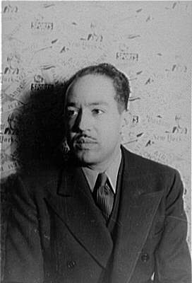
23. Identify three new pieces of technology during this decade.

24. What was the Harlem Renaissance?

25. Identify three figures from the Harlem Renaissance.

26. What was the message of the “Lost” generation?

27. What did Marcus Garvey advocate? What future figure did he inspire?
- Advocated:
- Inspired:

28. What groups did the KKK target?

The following questions are based on the Great Depression and New Deal.

29. What was the purpose of the New Deal?

30. Identify and describe 3 different New Deal programs.

31. How did the Supreme Court react to some New Deal programs?

32. What were the views of the following people as it relates to the Great Depression/government involvement in the economy?
- Dr. Townsend:
- Huey Long:
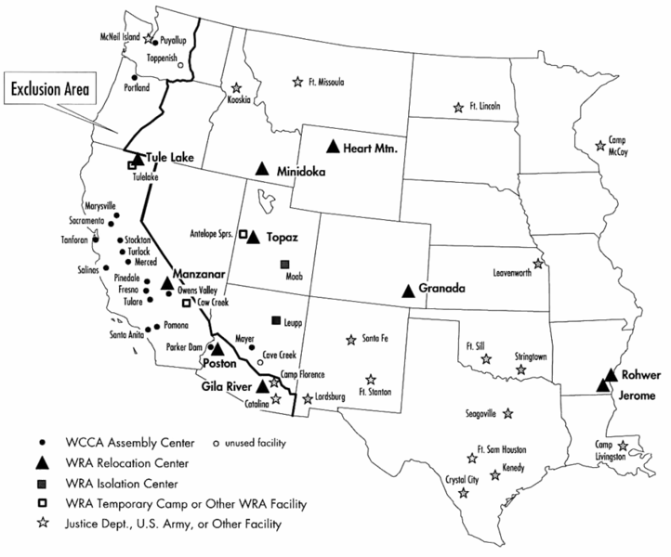
- John Maynard Keynes:

33. How did political realignment change as a result of the Great Depression and New Deal?

The following questions are based on World War II.

34. What was the impact of the Nye Committee?

35. Was the US “neutral” prior to World War II? Provide examples.

36. Why did the US enter World War II?

37. How did the war affect the following groups?
- Women:
- Japanese Americans:
- Mexican Americans:
- African Americans:

38. What was the Double V Campaign?

39. What was the Manhattan Project?

40. What did Stalin promise at the Yalta Conference?

41. Why did the United States use atomic weapons against Japan?

42. What is the “Sunbelt”? What happened to it during World War II?

Document Analysis

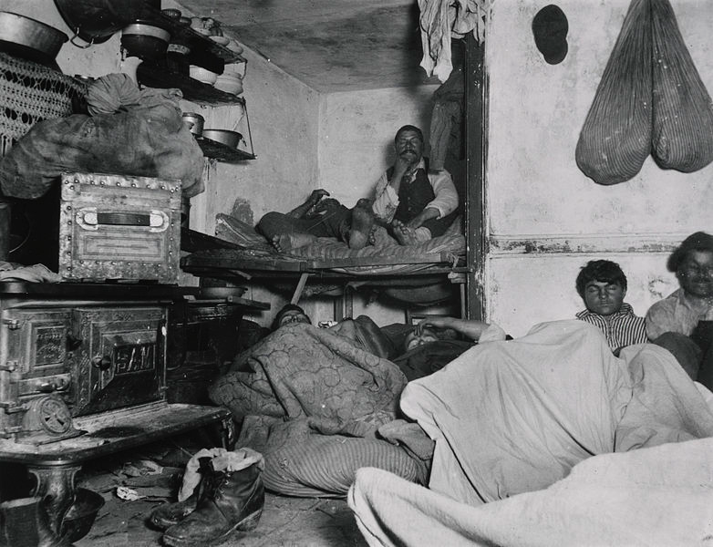
(Check out THIS video that break’s down the above photo)

1. Why did Riis use photography to spread his message?

2. How might people respond differently to photos than articles?

3. Why might people live in a small apartment?

4. How would a supporter of Social Darwinism view the people in the picture?

HIPP Analysis

1. What is the Historical Circumstance of this image?

2. Who is the Intended Audience of this image?

3. What is the Point of View of the image?

4. What is the Purpose of this image?

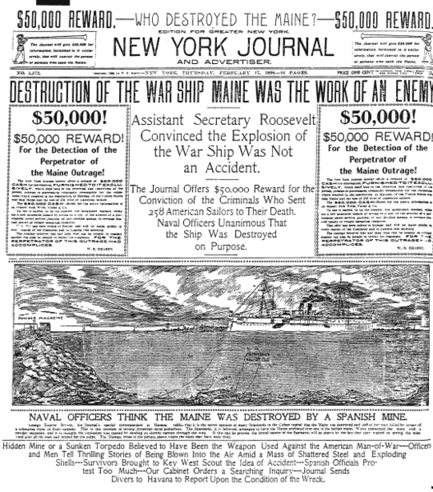
(Check out THIS video that break’s down the above document)

HIPP Analysis

1. What is the Historical Circumstance of this image?

2. Who is the Intended Audience of this image?

3. What is the Point of View of the image?

4. What is the Purpose of this image?

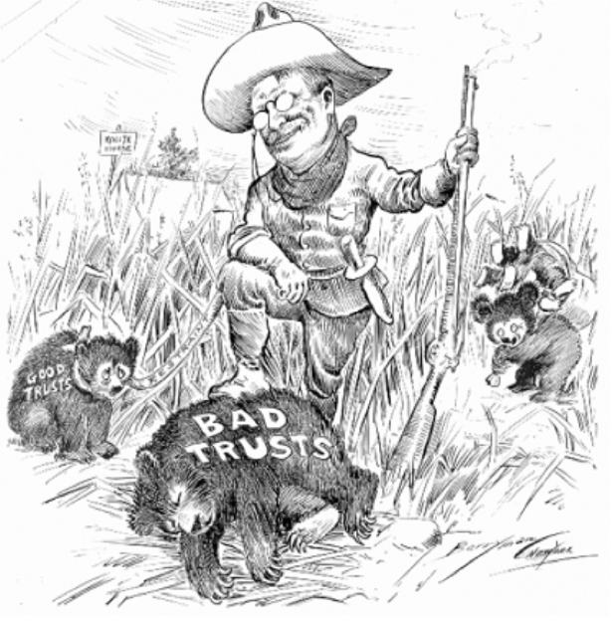
(Check out THIS video that breaks down the above cartoon)

1. What is the Historical Circumstance of this document?

2. Who is the Intended Audience of this document?

3. What is the Point of View of the document?

4. What is the Purpose of this document?

5. How would the following view the cartoon? (Support/oppose)
- JP Morgan:
- Progressive Reformers:
- Other Business Tycoons:

(Check out THIS video that breaks down the above cartoon)

1. What is the Historical Circumstance of this speech?

2. Who is the Intended Audience of this speech?

3. What is the Point of View of the speech?

4. What is the Purpose of this speech?

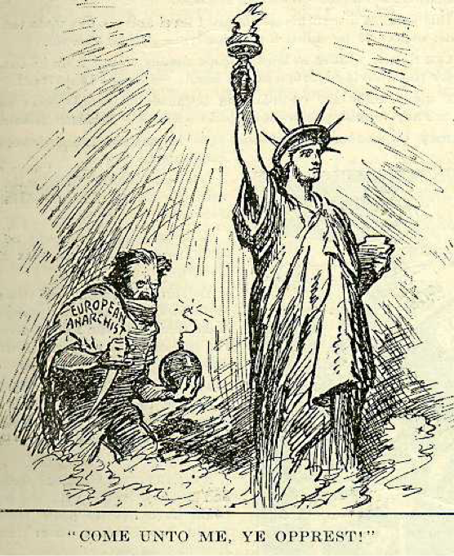
(Check out THIS video that breaks down the above cartoon)

HIPP Analysis

1. What is the Historical Circumstance of this document?

2. Who is the Intended Audience of this document?

3. What is the Point of View of the document?

4. What is the Purpose of this document?

“Since 1915 the colored population of Chicago has more than doubled, increasing in four years from a little over 50,000 to what is now estimated to be between 125,000 and 150,000. Most of them lived in the area bounded by the railroad on the west, 30th Street on the north, 40th Street on the south and Ellis Avenue on east. Already overcrowded, this so-called "Black Belt" could not possibly hold the doubled colored population. One cannot put ten gallons of water in a five-gallon pail. Although many Negroes had been living in "white" neighborhoods, the increased exodus from the old areas created an hysterical group of persons who formed "Property Owners' Associations" for the purpose of keeping intact white neighborhoods.…
In a number of cases during the period from January, 1918, to August, 1919, there were bombings of colored homes and houses occupied by Negroes outside of the "Black Belt." During this period no less than twenty bombings took place, yet only two persons have been arrested and neither of the two has been convicted, both cases being continued.”
Source: The document above was published in an African-American newspaper in 1919
(Check out THIS video that breaks down the above excerpt)

HIPP Analysis

1. What is the Historical Circumstance of this document?

2. Who is the Intended Audience of this document?

3. What is the Point of View of the document?

4. What is the Purpose of this document?

Unemployment Chart

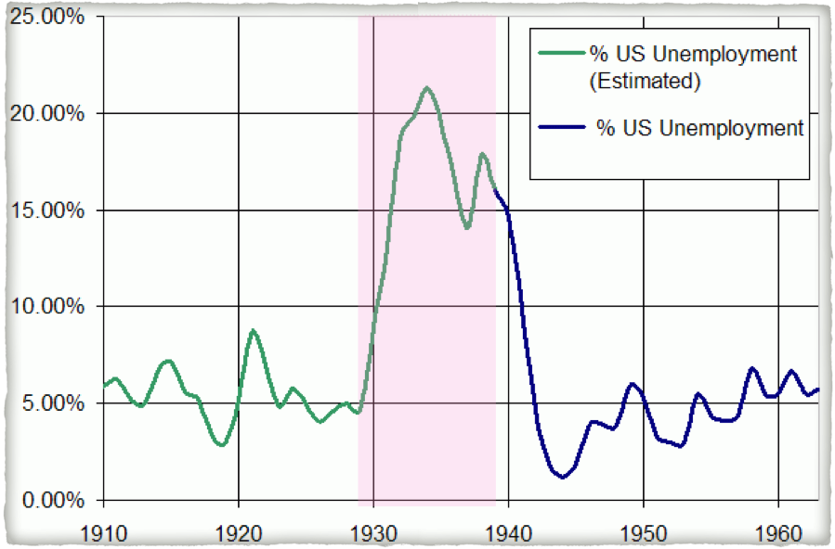
(Check out THIS video that breaks down the above excerpt)

1. What is the Historical Circumstance of this document?

2. Who is the Intended Audience of this document?

3. What is the Point of View of the document?

4. What is the Purpose of this document?

“By the afternoon of March 3, a week ago last Friday, scarcely a bank in the country was open to do business. Proclamations closing them in whole or in part had been issued by the governors in almost all of the states.

“It was then that I issued the proclamation providing for the national bank holiday, and this was the first step in the government’s reconstruction of our financial and economic fabric.

“Please let me make it clear to you that if your bank does not open the first day, you are by no means justified in believing that it will not open. A bank that opens on one of the subsequent days is in exactly the same status as the bank that opens tomorrow.

“The success of our whole national program depends, of course, on the cooperation of the public—on its intelligent support and its use of a reliable system.”
- FDR, First Fireside Chat – March, 1933
(Check out THIS video that breaks down the above excerpt)

1. What is the Historical Circumstance of this document?

2. Who is the Intended Audience of this document?

3. What is the Point of View of the document?

4. What is the Purpose of this document?

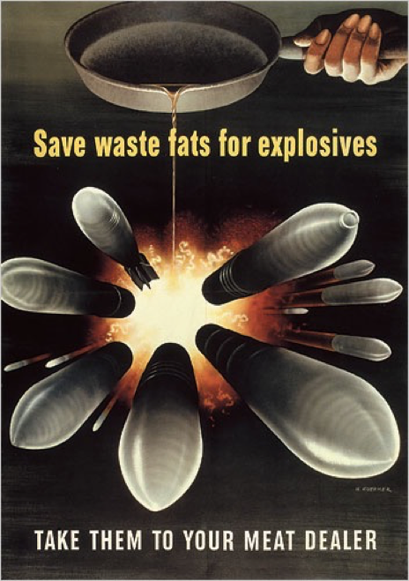
(Check out THIS video that breaks down the above excerpt)

1. What is the Historical Circumstance of this document?

2. Who is the Intended Audience of this document?

3. What is the Point of View of the document?

4. What is the Purpose of this document?

